Name: - Prithviraj Shevade.  
Domain: - Cloud Computing (AWS)

Task:-

Deploy a web application inspired by “The 50 Best Fantasy Manhwa You Must Read Now”.

The application should:

• Display a list of manhwa titles, their genres, and brief descriptions using mock data (e.g., a JSON file).

• Be hosted on a cloud platform (AWS, Azure, or GCP) with a basic infrastructure setup, including:

• An EC2 instance or an App Service for hosting.

• A storage solution like S3 (AWS) or Blob Storage (Azure) for storing images

. • A basic database (e.g., RDS or Cloud SQL) for managing the manhwa data.

• Set up auto-scaling for your application so it can handle traffic spikes. Document how auto scaling is configured and what triggers it (e.g., CPU usage).

• Implement security measures by: • Enabling HTTPS for the application using a cloud service (e.g., AWS Certificate Manager or Azure SSL).

• Configuring basic firewall rules to restrict access to necessary ports.

Here is my work:-

* First I have created the JSON file that I will attach in submission box or I will upload it on github and provide u link.
* I have created the VPC and subnets to launch the application.

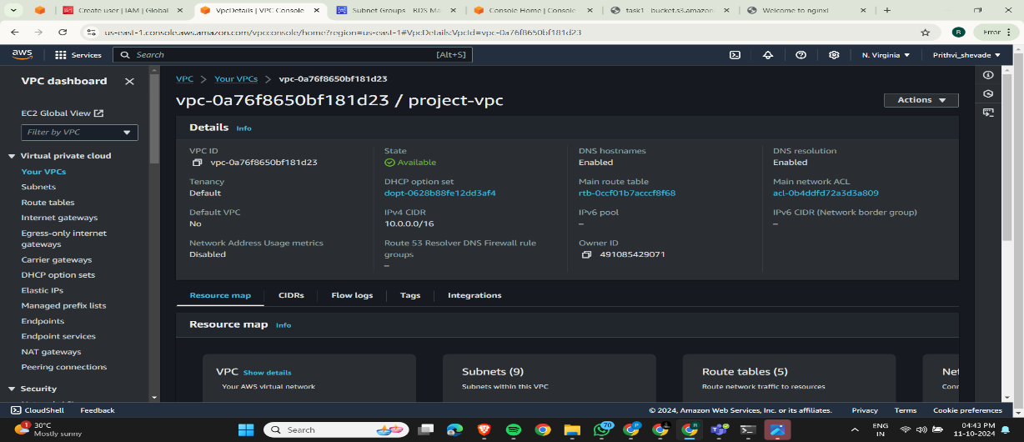

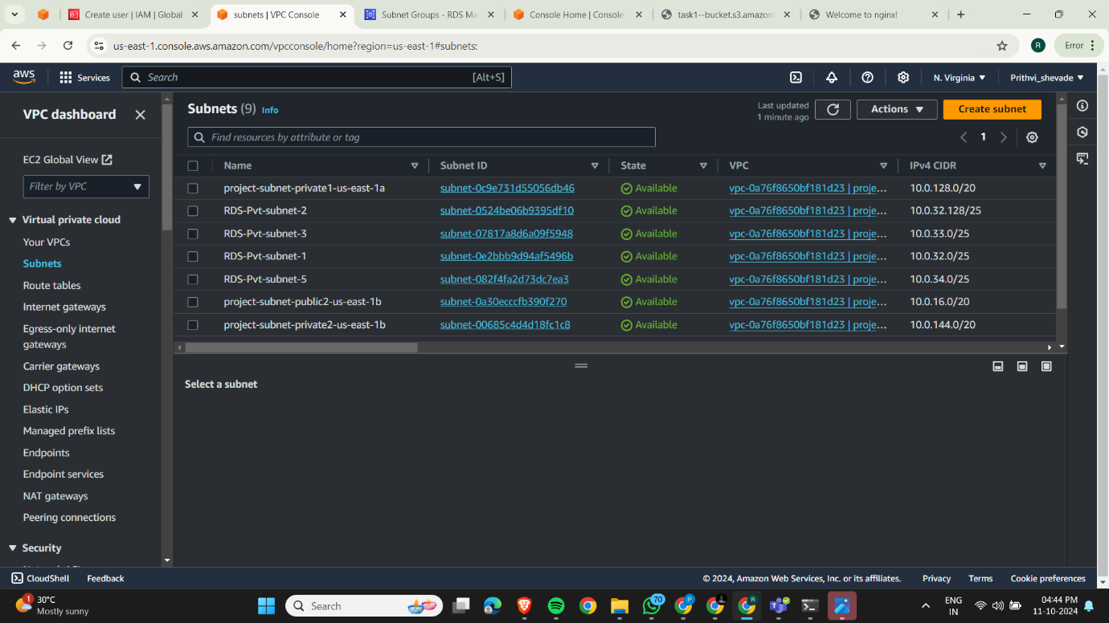Subnet:-

* After that I have created the Route Table and that attached to the Subnet and I have also created the Internet Gateway and attached to VPC

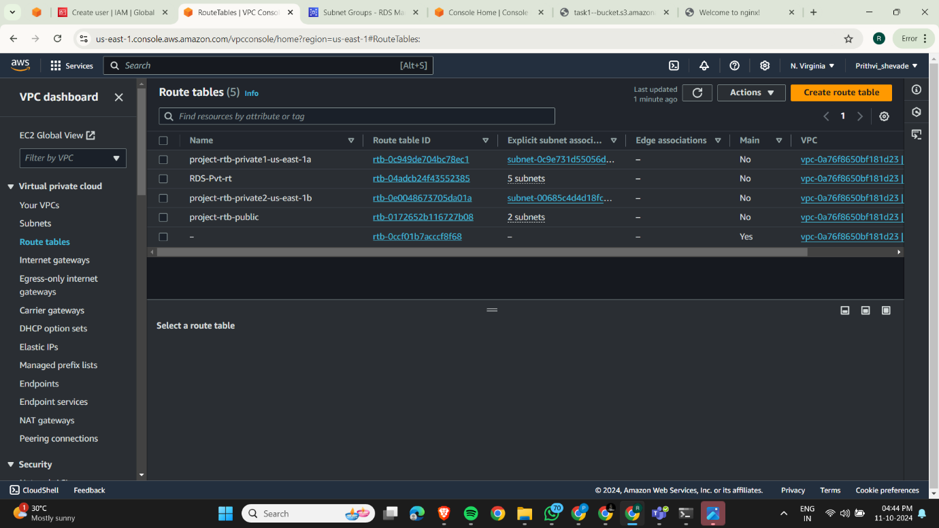

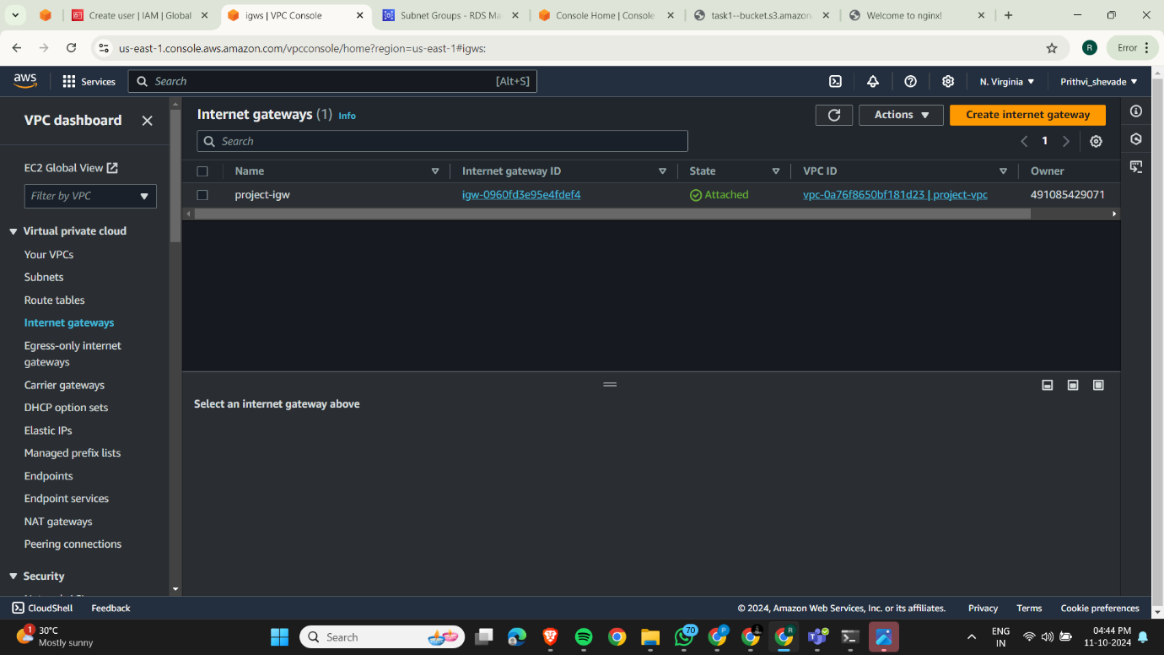

* Now here I have created the EC2 Instance and their configurations.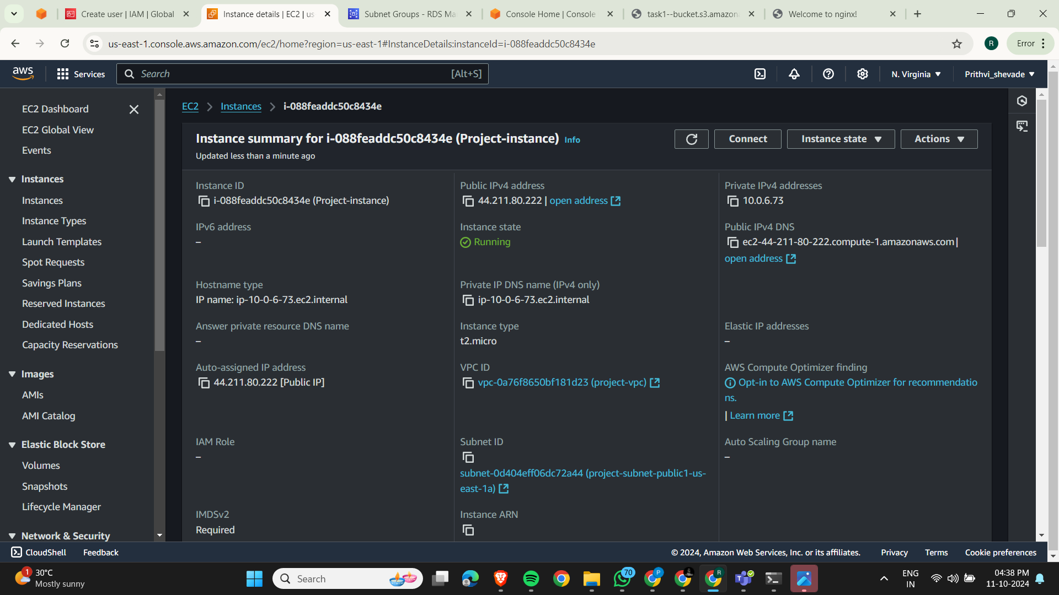
* SSH into your EC2 instance and install web server
* 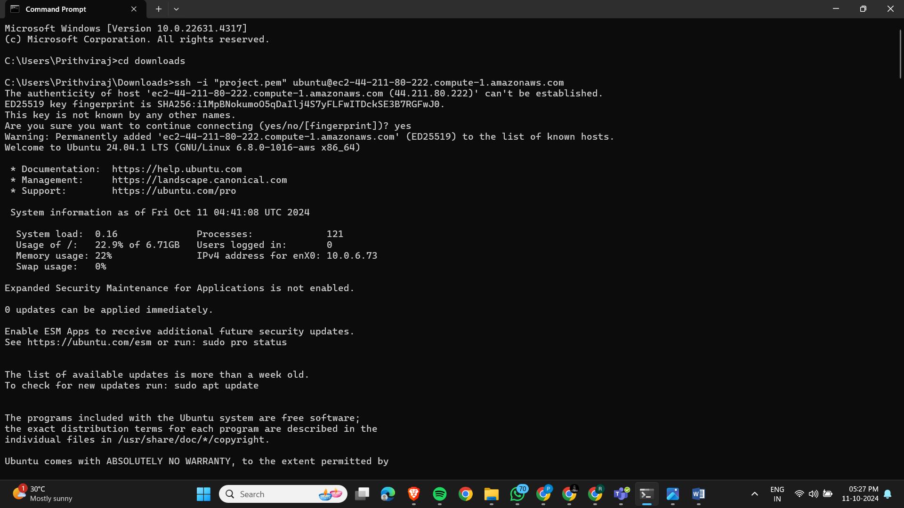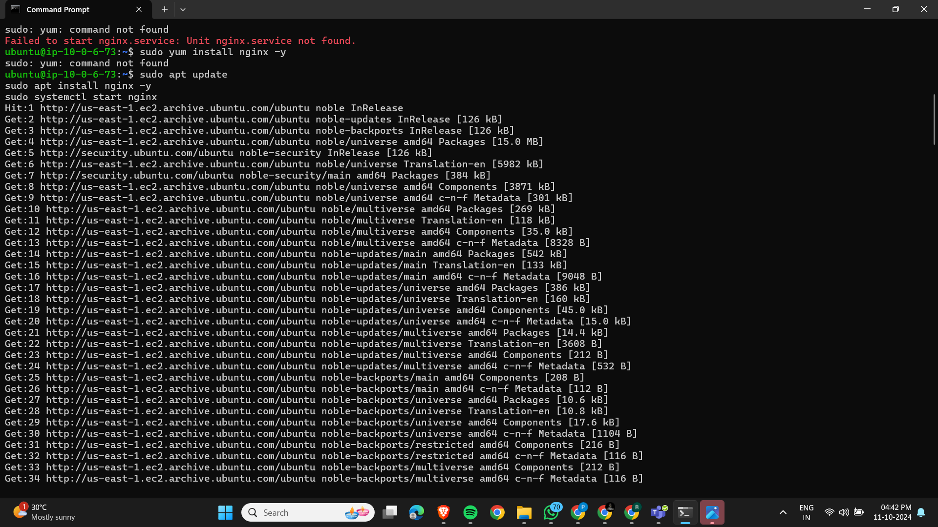
* Set Up Storage (S3) and add policies

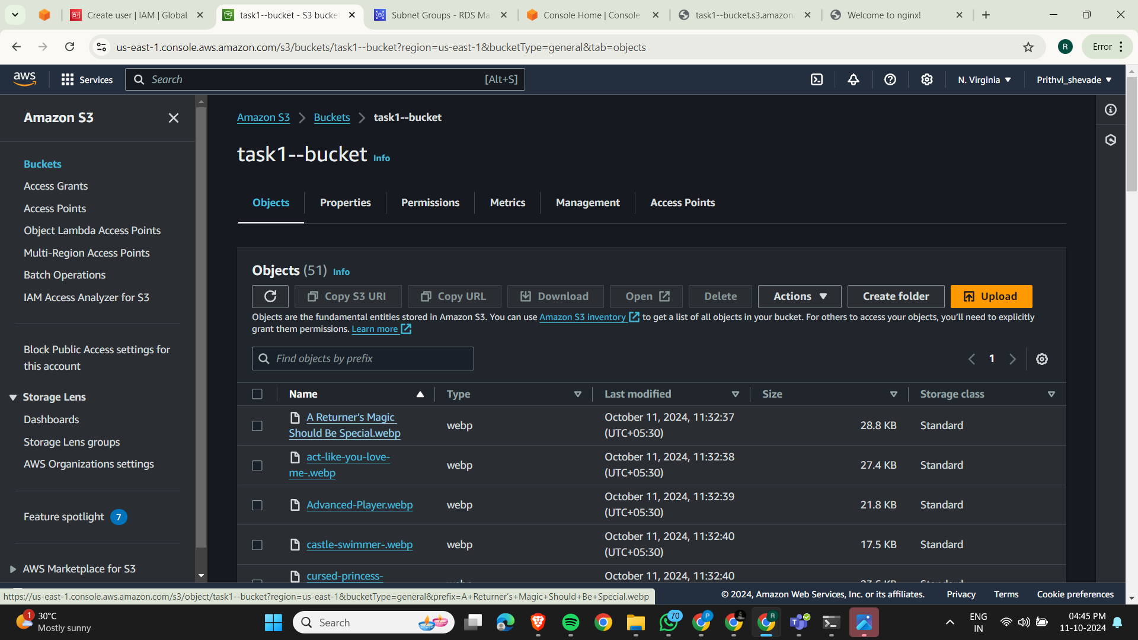

* 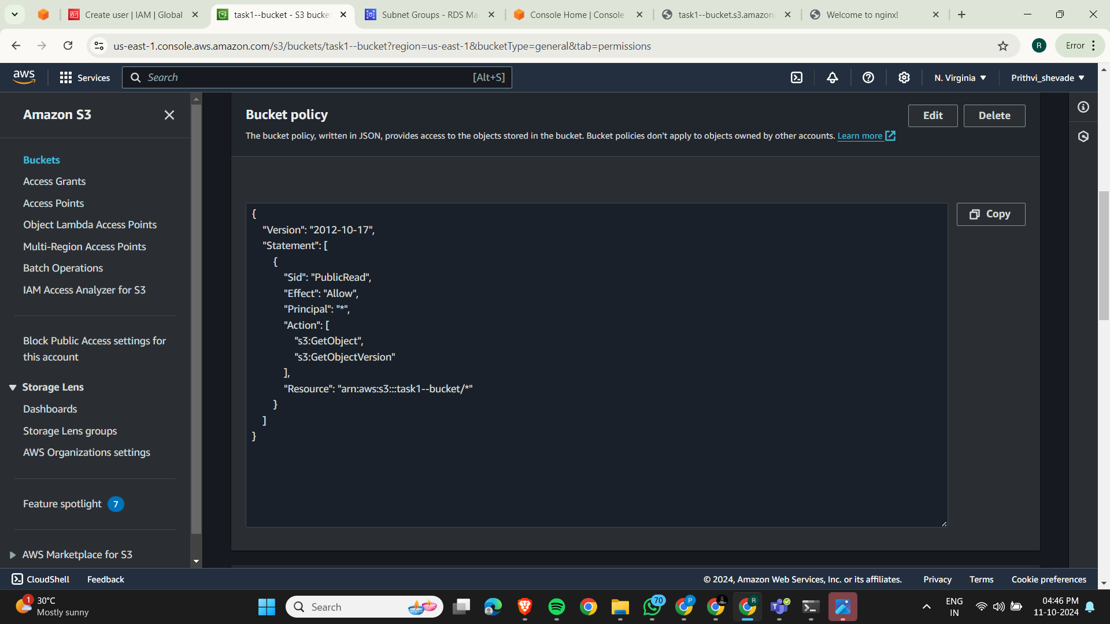
* RDS Setup:-

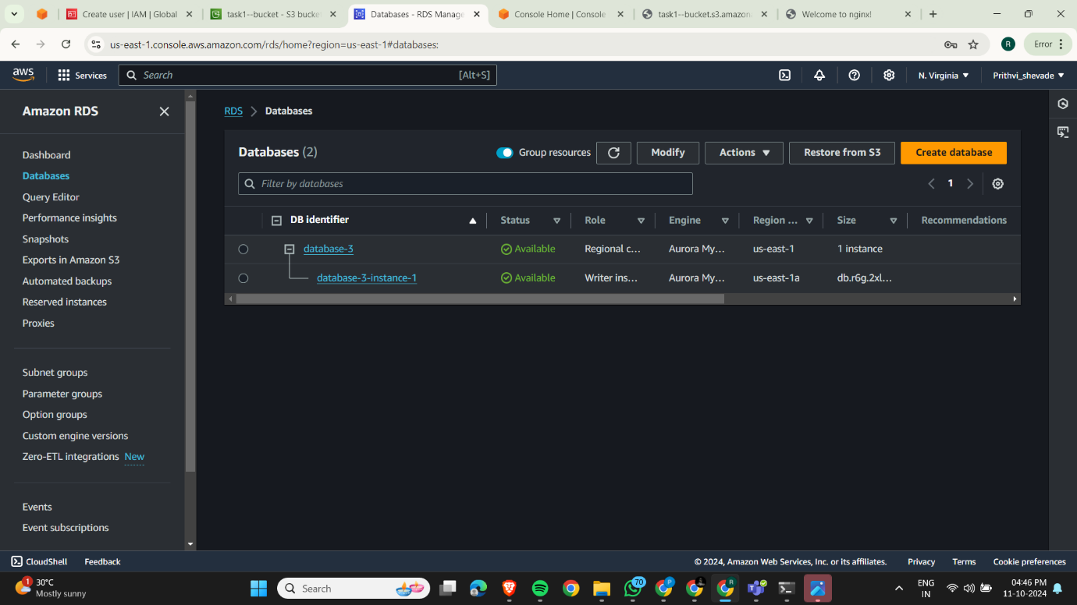

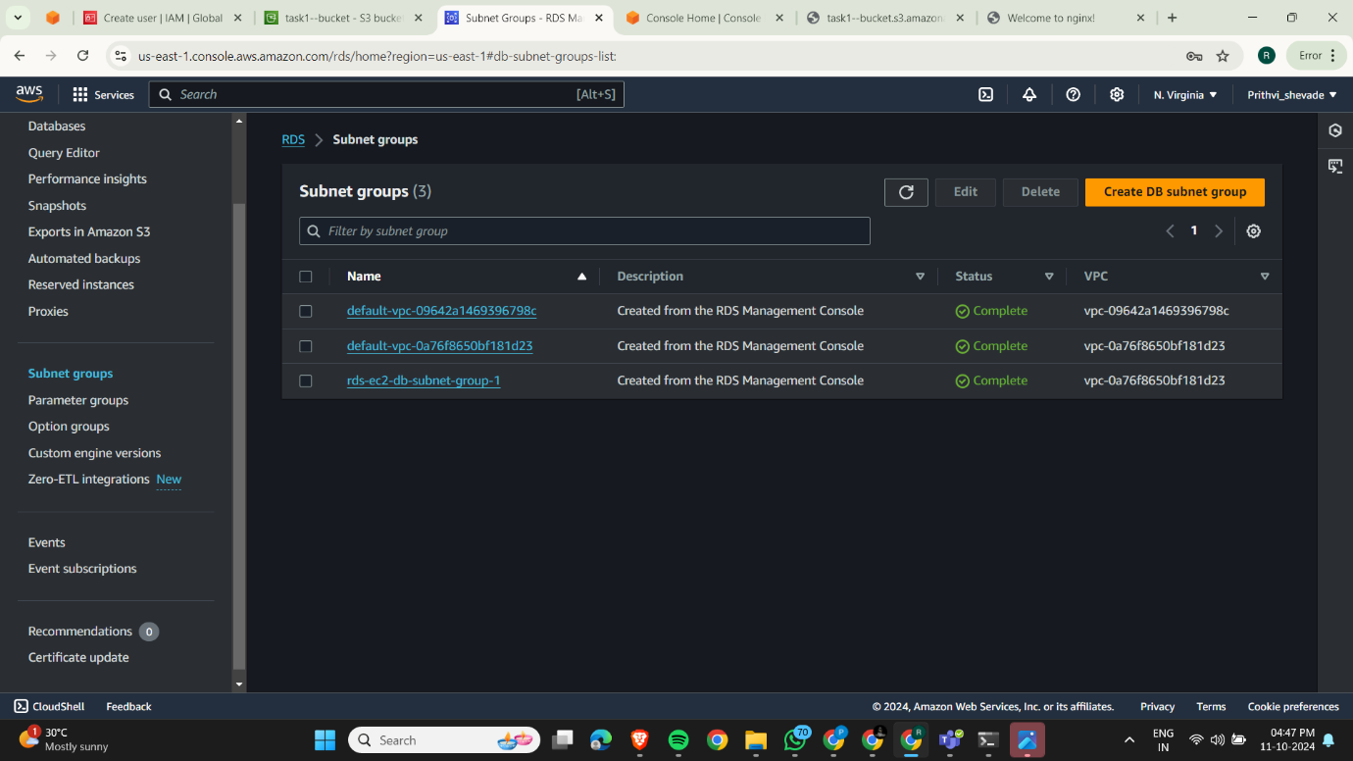

* 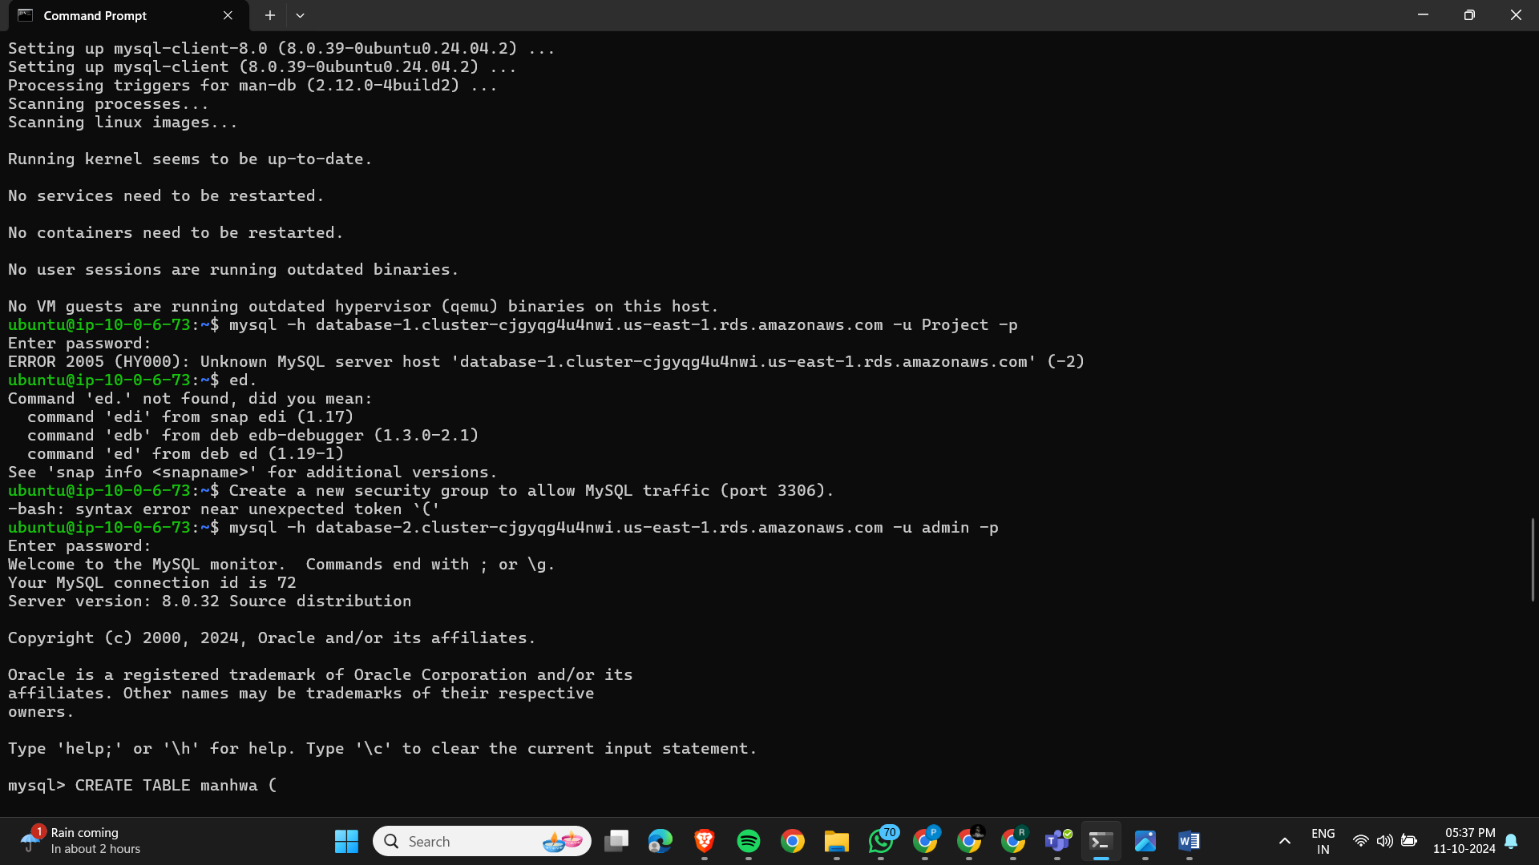**Connect to RDS from EC2**:
* **Configure Auto-Scaling**

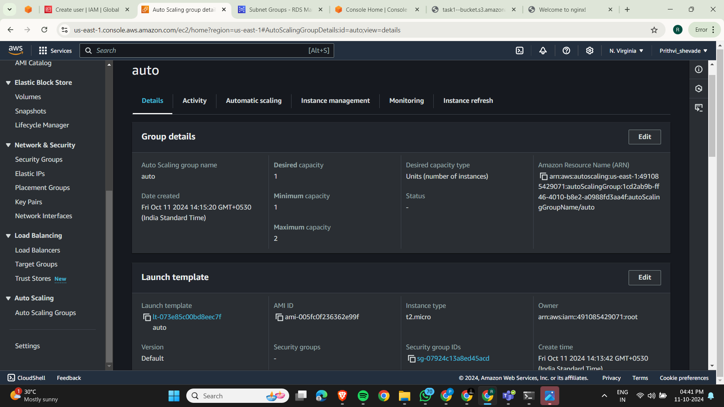

* **Auto Template:-**

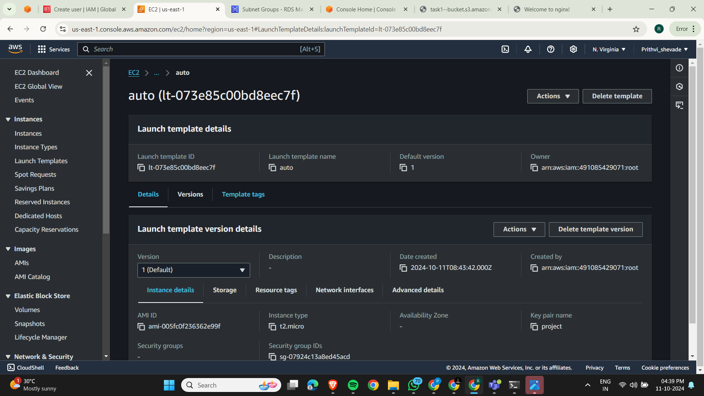

**Enable HTTPS**

* **Use AWS Certificate Manager (ACM)**: I have applied and kept it whole night to get issued but it can’t get issued. And I have also configured through route 53 by providing CNAME and VALUE.

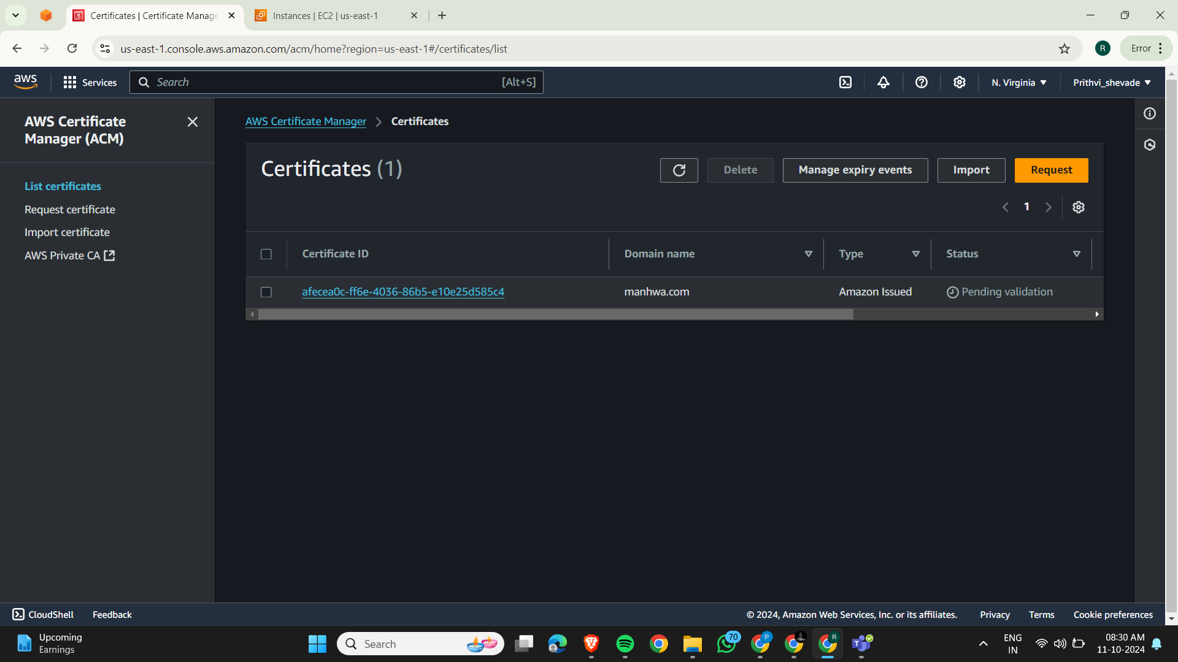

* **Configure Firewall Rules**

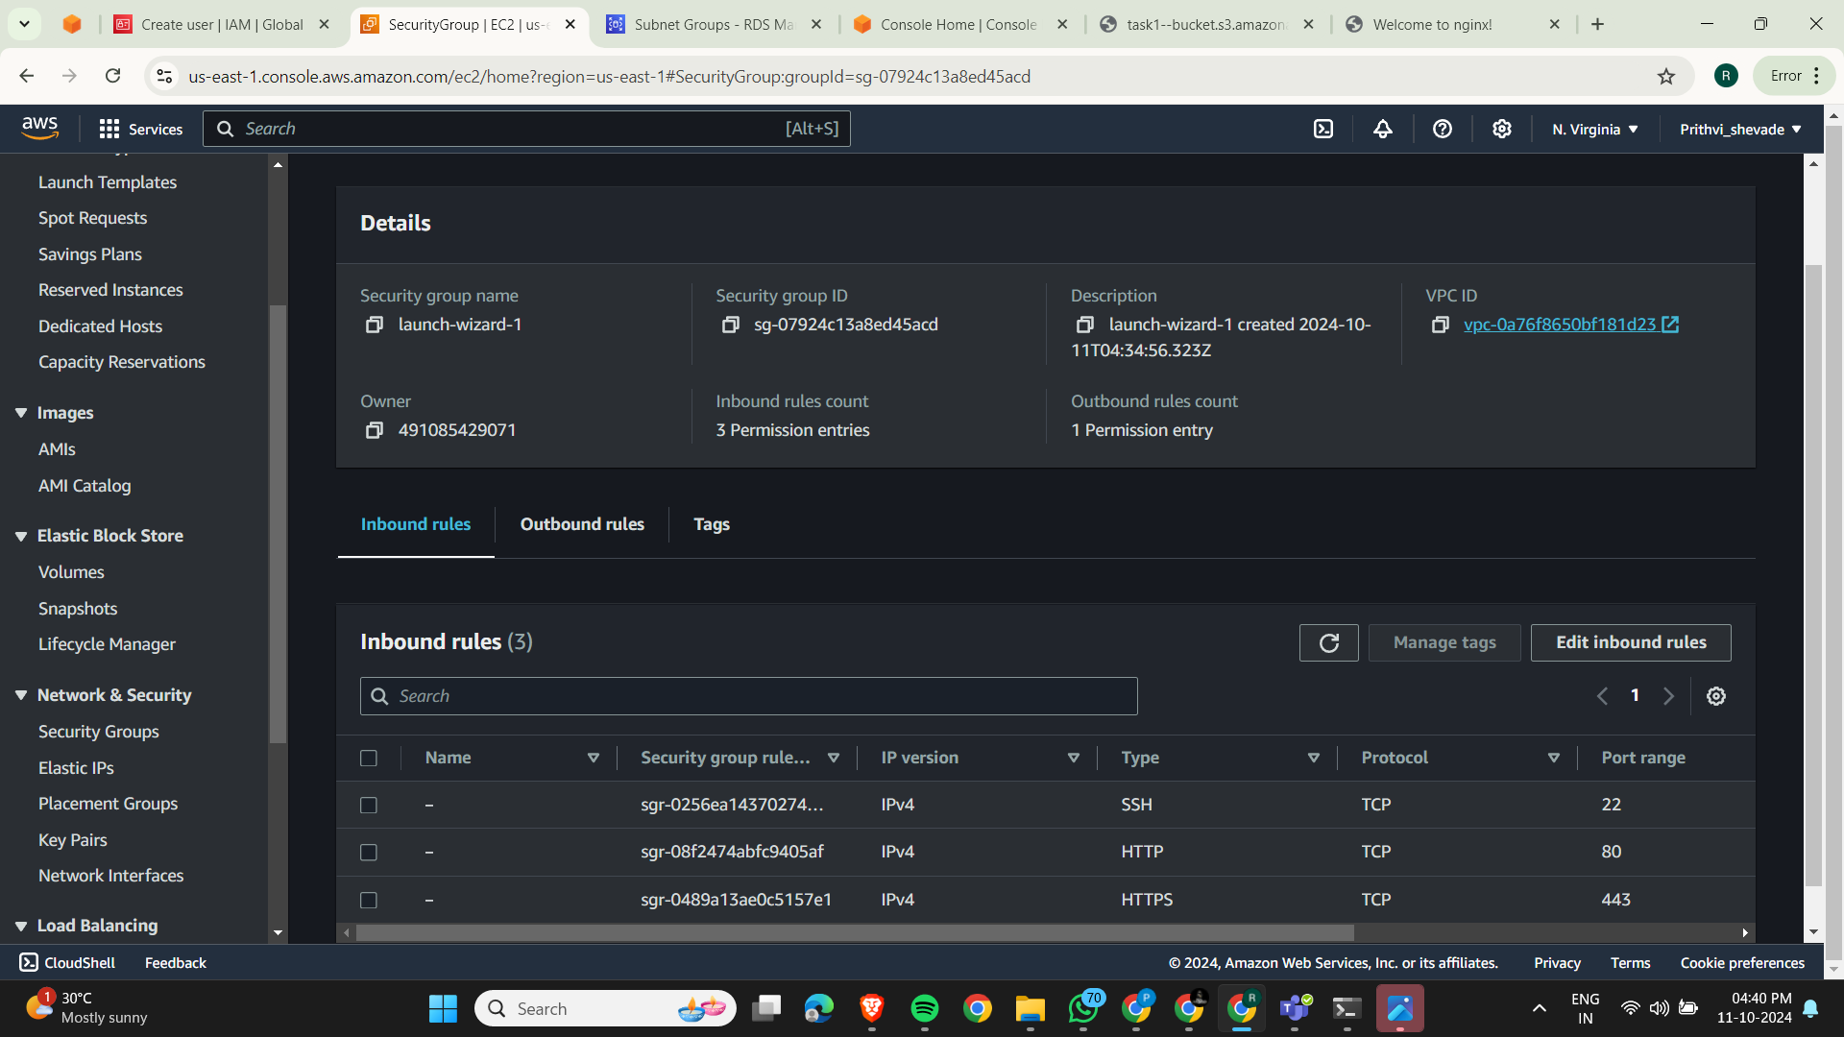

**Test Your Application: -** "I sincerely apologize for not being able to successfully deploy the project despite my best efforts. I will continue to work on improving and learning from this experience."

Here is My Instance Public IP Result:-

